If-then Scripts:

- Check the variable
- #!/bin/bash
- count=100
- if [ $count -eq 100 ]
- then
- echo Count is 100
- else
- echo Count is not 100
- fi
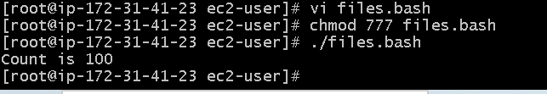

Check if a file error.txt exist
- #!/bin/bash
- clear
- if [ -e /home/iafzal/error.txt ]
- then
- echo "File exist"
- else
- echo "File does not exist"
- fi
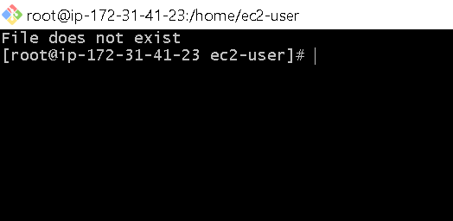

Check if a variable value is met
- #!/bin/bash
- a=`date | awk '{print $1}'`
- if [ "$a" == Mon ]
- then
- echo Today is $a
- else
- echo Today is not Monday
- fi
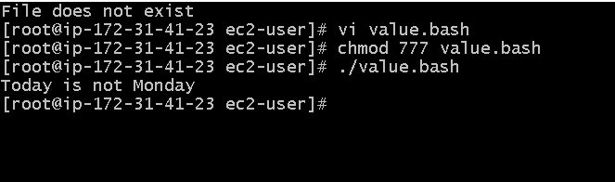

Check the response and then output
- #!/bin/bash
- clear
- echo
- echo "What is your name?"
- echo
- read a
- echo
- echo Hello $a sir
- echo
- echo "Do you like working in IT? (y/n)"
- read Like
- echo
- if [ "$Like" == y ]
- then
- echo You are cool
- elif [ "$Like" == n ]
- then
- echo You should try IT, it’s a good field
- echo
- fi

